RED KNIGHTS MOTORCYCLE CLUB ®
Pennsylvania Chapter 8
Heather Morris - TREASURER
3677 Northern Pike
Monroeville, PA 15146
Tel. 412-389-5189
E-Mail: PA8@RedKnightsMC.com
TMLA File Number PA 08-27

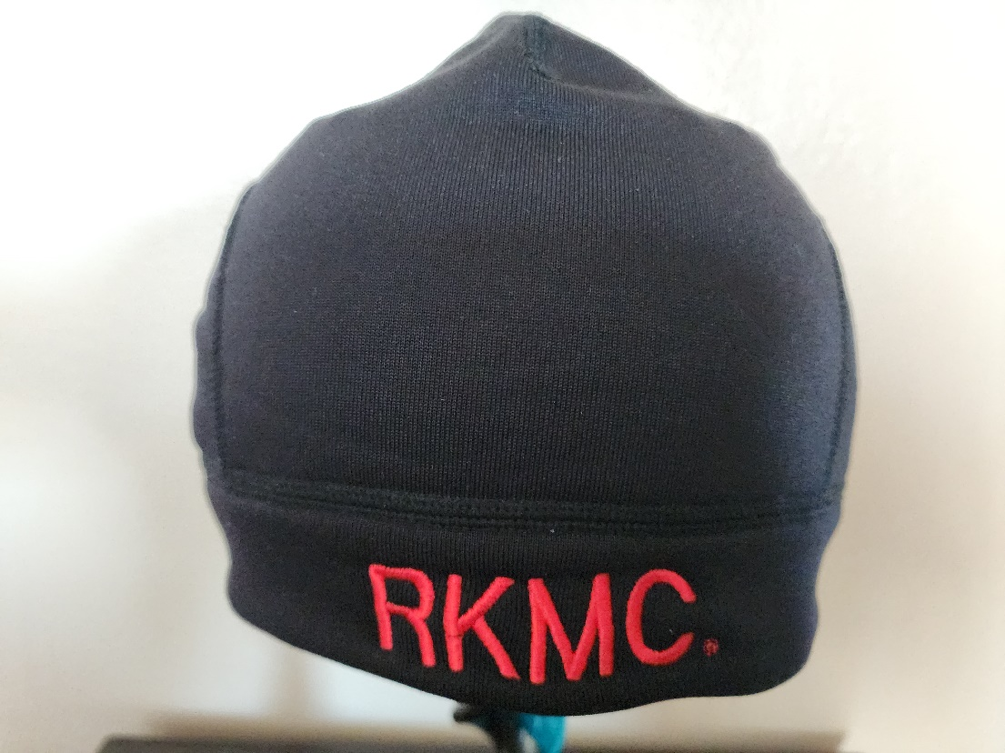

☐Automotive
☐Automotive-Misc
☐Automotive-Motorcycle
☐Coin, Patches, Pins
☐Clothing
☒Clothing-Hats
☐Clothing-Misc
☐Clothing-Vest/Vest Items
☐Clothing-Women’s
☐Decals/Stickers
☐Flags
☐Housewares-Beverage Items
☐Housewares-Misc.
☐Misc. Items

Item | Description | Color | Quantity | Cost ea. | Total
1 | RKMC Embroidered Polartec Power Stretch Beanie  (One Size Fits All) | Black & Red |  | $25
Sub Total
Shipping and handling fees (Add $1.00/item to Continental U.S.
or Call/Email For International Cost)
Total
Please make check/money order out to: Red Knights MC PA8
Or PayPal to: Mail@RedKnights.org
Please allow 6-8 weeks for delivery of items not in stock
All Prices US currency / Prices subject to change without notice
All items MUST be prepaid

